2d Platformer Design:

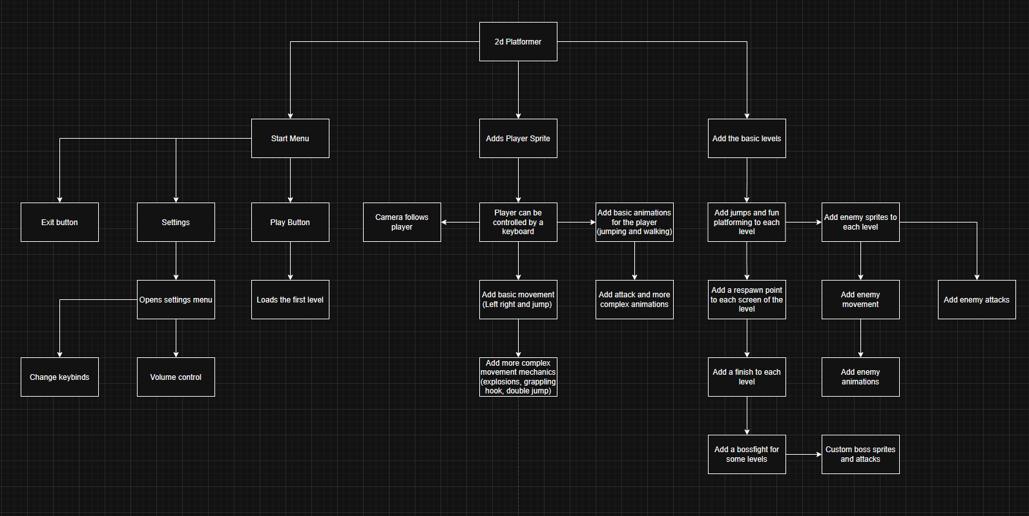Structure Diagram:

This structure diagram is split into 3 parts,

## Stages of Development Plan:

**Stage 1:**

Before I go in depth for any feature of the project, like mechanics, level design and user interface, I should make a simple version of the game. This will include simple movement and a few jumps to test everything works properly.

## The simple version will have the following features:

The ability to move left, right and jump, make sure that the movement is enjoyable and responsive from the start.

Add some objects to the scene to see how they interact as they should, e.g being able to stand on top/ not walk through.

Add a respawn platform for the player to go to when they die/fall off the map.

|  |  |  |  |  |  |
| --- | --- | --- | --- | --- | --- |
| Test No. | Description | Type of test | Test data | Expected Result | Actual Result |
| 1 | Can the player  move? |  | Input movement  button | Player moves | Yes |
| 2 | Does the camera  follow the player? |  | Input movement button | Camera moves with the player | Yes |

|  |  |  |  |  |  |
| --- | --- | --- | --- | --- | --- |
| 3 | Can the player  interact with objects? |  | Place player on top of a platform | Player stands on top | yes |
| 4 | Does the player respawn? |  | Move the player off the map | Player is placed back on its  respawn point | Yes |
| 5 | Can the player  jump? |  | Input the jump  button | Player jumps | Not working |

## Stage 2:

To make the game more complex, I will have to add more features to the game, this includes more movement mechanics and. The first of these will be a double jump, which hopefully is the simplest, and a rope that can be used to swing. I will also add a start menu and a pause menu during the game.

# The 2nd version will have the following features:

A menu that appears when the game starts that lets you start the game or enter settings.

A pause menu that will let you return to the menu during the game.

A double jump that allows the player to jump again while already in the air, potentially playing an animation, letting the player jump further.

A rope/grappling hook that can be thrown/shot to attach to the ceiling, to let the player swing across a gap that would otherwise be too large to travel across

|  |  |  |  |  |  |
| --- | --- | --- | --- | --- | --- |
| Test No. | Description | Type of test | Test data | Expected Result | Actual Result |
| 1 | Does the game start? |  | Press start | Scene, and  sprites appear |  |
| 2 | Does a pause menu  appear? |  | Press the  pause button | Pause menu appears |  |
| 3 | Can the player double  jump? |  | Press space twice | Player can jump |  |

|  |  |  |  |  |  |
| --- | --- | --- | --- | --- | --- |
| 4 | Can the rope  attach to the ceiling |  | Touch the two objects | Rope attaches to  the object |  |

|  |  |  |  |  |  |
| --- | --- | --- | --- | --- | --- |
| 5 |  |  |  |  |  |

## Stage 3:

After adding more complex mechanics to the game, I would like to start making it more playable and fun. This means adding things like enemies and fighting, plus changing features to be higher quality.

# The 3rd version will have the following features:

Enemies that can move towards or fire objects at the player, when I create these, I will have a generic enemy class and then have more enemies that inherit from that class. The player should also be able to take damage from these attacks or by touching an enemy. But they can fight back using the tools they have been given (bomb/grappling hook) to damage the enemies.

|  |  |  |  |  |  |
| --- | --- | --- | --- | --- | --- |
| Test No. | Description | Type of test | Test data | Expected Result | Actual Result |
| 1 | Do the enemies try to attack the player? |  | Move player towards enemy. | Enemies aggress towards the player, once they get  close enough |  |
| 2 | Does an animation play when the enemies move? |  | Move the enemy | Movement animation plays |  |
| 3 | When hit by an attack, does the player take damage/get  reset? |  | Player touches component that damages them | Teleported to the beginning of the screen |  |
| 4 | Do the enemies take damage from the player’s  attacks? |  | Enemy touches player attack. | Enemy takes damage/ disappears. |  |
| 5 | Is the player able to attack? |  | Press attack key | Player attacks |  |
| 6 | Does an animation play while  attacking? |  | Press attack key | Attack animation plays |  |

## GUI Design:

Background contains scenes from the game, so the placeholder colour is blue, as it is abundant due to the game being outside

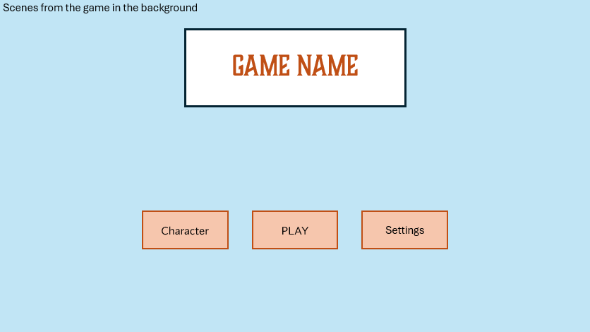

Each button takes the user to its respective page

When the settings button of the previous layout is pressed, this page will appear. There is a title at the top of the page telling the user it is the settings, plus an icon, just in case the user isn’t able to read English. This tells them they are in the settings. Below the title, there are different sliders and buttons you can press. For the sliders, there are contrasting colours: orange and white, which is a good visual representation to show how far along it is. Similarly, the buttons have that feature, where it is obvious if they are on or not. These are helpful as they make navigating settings as easy as possible.

The game will open to this page which contains the title of the game, and multiple buttons below. I have done it in this way as it makes the name more prominent, letting the player know what game it is instantly, as opposed to something else being more noticeable, making the game name less obvious. The buttons are just below the title, in an easy-to-read font that stands out compared to the orange background. I have decided to use the colour orange as it stands out against the blue background, which is blue as it will contain backgrounds from the game, which is mainly set outside, with a blue sky.

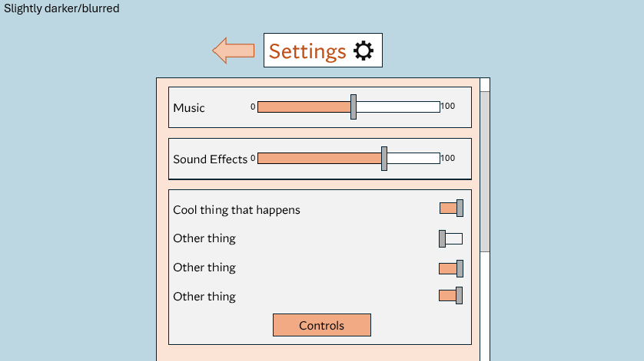

The settings background is slightly darker compared to the main menu, the background will also become blurred; I think this helps to indicate that it is a sub- page and take the attention away from the background and focus on the main point of the page

Back arrow indicates that it will bring the user back to the main menu. This is used instead of ‘back’ as it became too cluttered with words and I preferred it to be more simple

After the Controls button has been pressed, this page appears, it shows the user what each key does in game, this is helpful in case they do not know. The background is a different colour to the key binds’ background, this makes them stand out more and easier to see. I have also used a keyboard icon next to the title to help indicate the usage of the page, like the settings icon. The user can also change the keys by clicking on them. There is also a

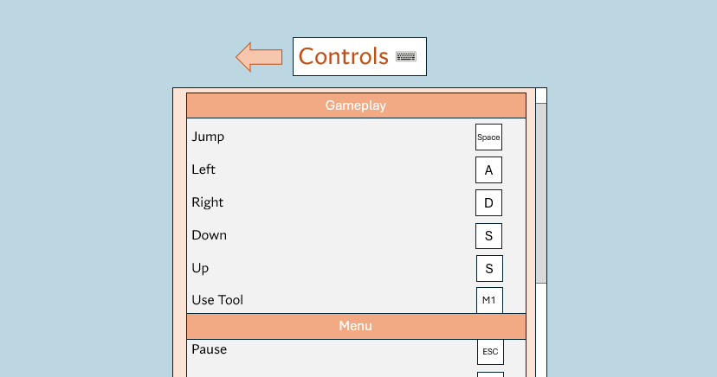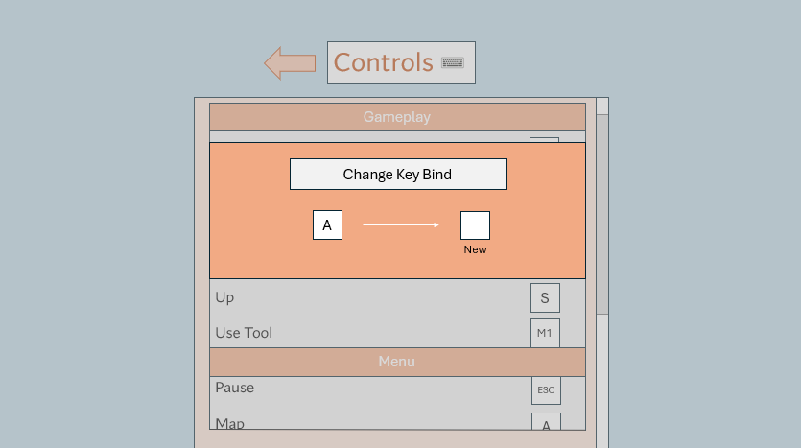

Clicking this will allow the user to change the key the action is bound to

When the user tries to change their key binds, this window will appear, where they can press any button to change the key. The background becomes darker as it takes attention away and places it on the new window. It is orange as it matches with the colour scheme of the other components of the GUI.

The background is again darker, to indicate what page the game is focused on.

The Customisation page is clearly labelled at the top, I would like to add an icon, like an item of clothing or something similar. The character is located in the middle of the screen, surrounded by windows that can be used to change the design. On the left, it is clearly labelled ‘clothing’ and there are

arrows on each component that can be used to cycle along to the next one. This Is the

same for the ‘appearance’ window, but the height has a slider. I chose this over something else like a set height/ a few set heights, as it allows the user to fully customize the character. And there are a few select colours to choose from.

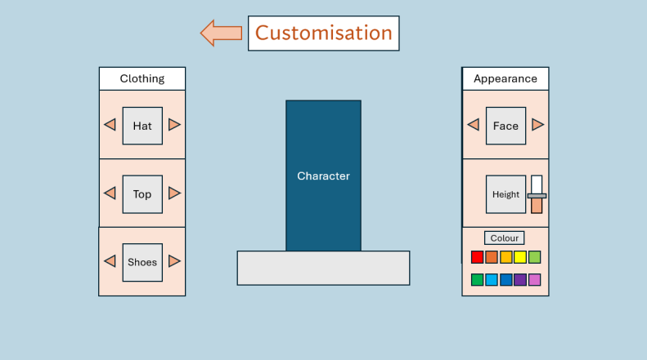

Large arrow to indicate

that it will take the user back to the main menu.

Allows the user to cycle along the different options/ change the appearance

The level select screen contains a list of the different levels the user has unlocked, in the form of multiple different images in a row. Levels that haven’t been unlocked are hidden behind a lock icon and potentially a blurry image of the level to be unlocked.

There are arrows to the left and right of the ‘Play Level’ button, which can be used to scroll along the row. When the level is the one that can be selected, it is larger, indicating it’s the one the user is on.

Large arrow to indicate that it will take the user back to the main menu.

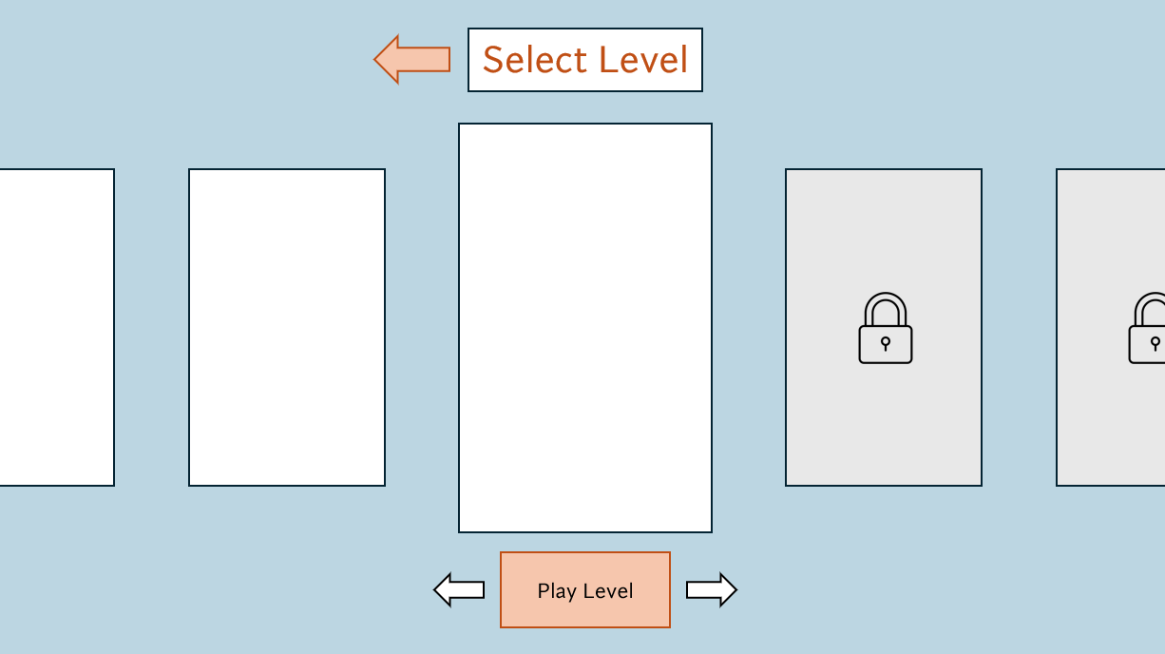

Larger level image to show it’s the one selected.

Locked levels have a lock icon covering the image.

## Development:

Player:

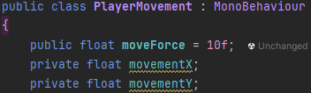he first thing I wanted to do was make the player move. I started off by creating a variable named speed, which will decide how fast the player moves, I later changed this to moveForce as I think it better describes how it affects the player. At first, I also used the transform function to move the player, which changes the player’s position, but later changed it to directly affect the rigidbody of the player, which is better for physics-based movement which I would like. I also declared variables movementX and movementY, these are the directions that the player will move.

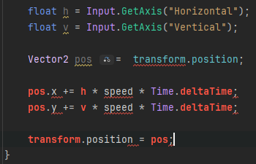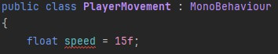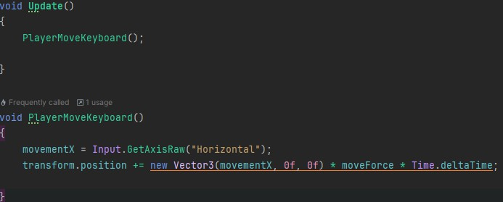

I then made a function which checks what button is pressed on the keyboard in ‘GetAxisRaw’ and adds it to the transform position equation. This multiplies the x position, moveForce and Time.deltaTime to move the player.

Program was not running. Fixed by changing ‘Active Input Handling’ to ‘both

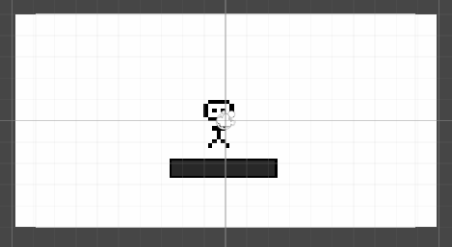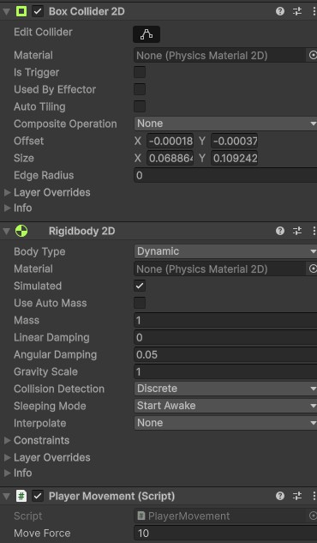

Camera:

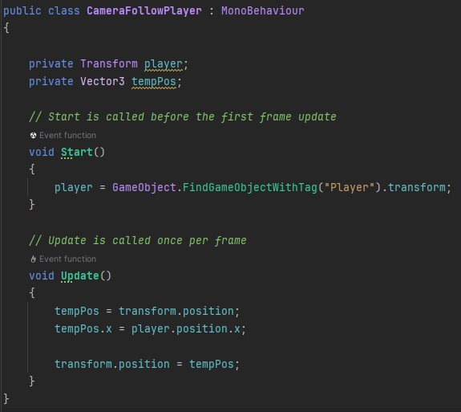

Does not follow player

This is because the character is not tagged as ‘Player’ in unity. So, I renamed it to player for it to work

Camera only followed player horizontally, added a Y direction that would follow the player vertically.

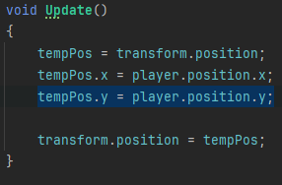

Tools:

Added a placeholder grappling hook that the player could hold. At first, I thought I could attach the player movement script to it and have them move together, but that didn’t work.

(Unity, 2025)

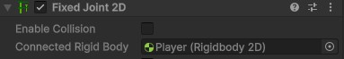

I used this to connect the player and the grappling hook

I wanted to have the tool point towards the player’s mouse cursor.

(Brackeys, 2025) – this video on top-down shooting provides code that makes the player look at the mouse position. I watched that section of the video and used the in-built functions I had learned to add it to my program.

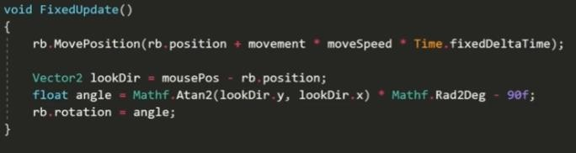

I then added my textures that I had made, of a city street

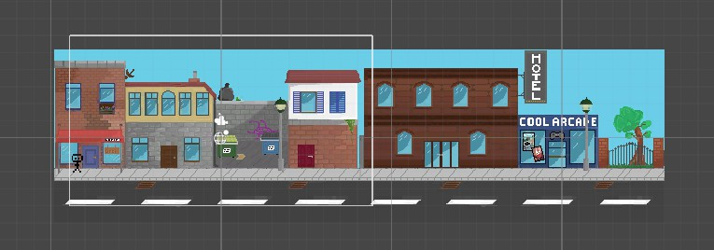

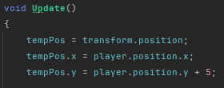But the camera wasn’t focused on the street, and you could see outside, which I didn’t want

I added 5 to the position of the camera to see how that would affect it. I then settled on 5/2 being a good number to use as you could see the whole of the scene.

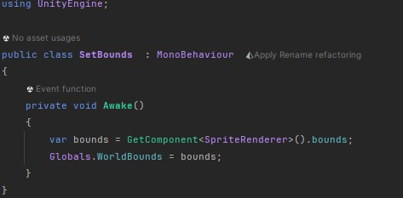I then wanted the camera the stop when the player reaches the end of the street, I couldn’t figure out how to do this, so I watched a tutorial that (chonk, 2025) showed me how, and then I used what I had learned to code it into my game.

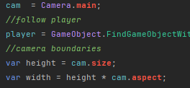



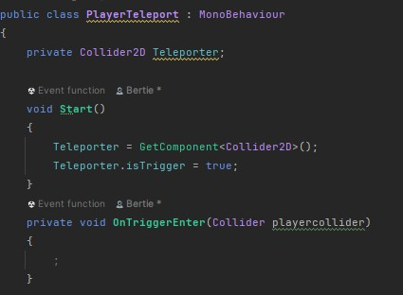To move the player between levels, I have decided I want to have them teleport in game to change the scene, to test this, I made 2 portals and had the player teleport between them. I also want the screen to momentarily turn black to make the transition more seamless, as I will use this often, it will be a public function so it can be used all the time. (Unity, 2025) helped me to use the isTrigger function and onTriggerEnter to check if the player was touching the portal.

I haven’t added anything to the function yet as I need to add a collider for the player.

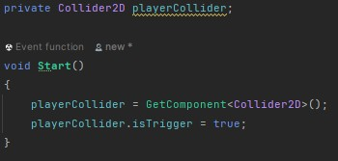

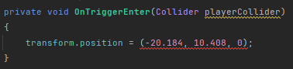

I tried just changing the position of the player when they entered the portal, but that didn’t work. I then

added an f after each number to specify a float, with a vector3 object. This came back with no errors



When I started the program, the player kept falling through the floor, I didn’t know if it was a problem with the player or the ground, so I made a new object of a 2d box, the box fell and landed on the ground so I knew it was a problem with the player object.

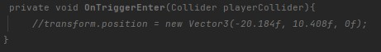

I temporarily removed the code I had just added and it worked, because the isTrigger box being selected was removing the collision.

After this, the player wasn’t being teleported, so I created a new object called PlayerCollider which moved with the player and moved the collider code from the player to a new script attached to that object.

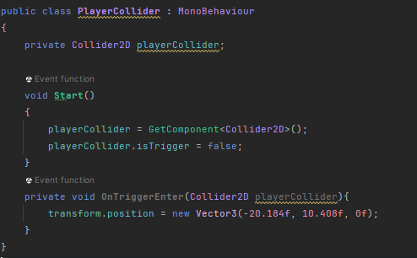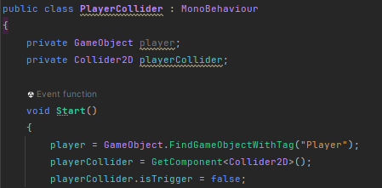

This code ran, but it still didn’t work, so I decided to teleport the player using a button that the player

clicks when they get close to the teleporter. I made the previous code a comment.

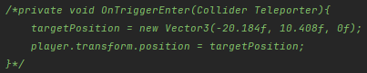

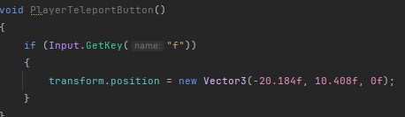I added this function that just checks for when the ‘F’ key is pressed, I chose F as it is close to the WASD and E controls which are used in the game. And this moved the player to the correct position

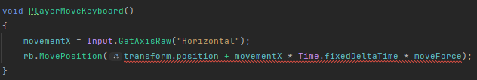Then I added a barrier to stop the player falling off the map, but the player could walk through it, so I changed the movement from transform.position to Rigidbody2d.MovePosition. (Unity, 2025)

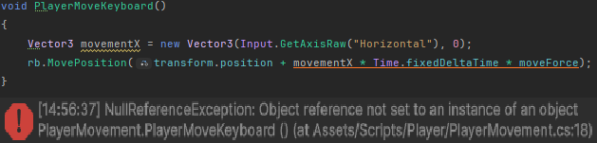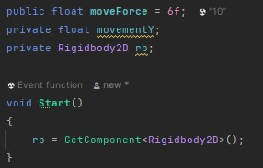This didn’t work at first, but then I changed movementX to Vector3 and removed the line initializing it as a float. And there were no errors, until I ran the program and there was a continuous error, I didn’t know what was wrong, so I used this site (plbm, 2025) to help me figure out why.

I then added this line inside of the start function which referenced the rigidbody, which applies a force to the rigid body instead of just changing the position with transform. This worked, the player moves and cannot move through the barrier I placed.

I now wanted to make the player jump, as I had sorted out the movement.

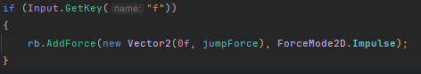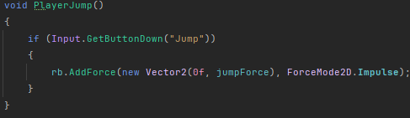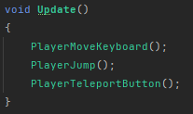

I added a function named PlayerJump to void Update, as that is called every frame, so it will always be checking for a button to be pressed. I added the impulse mode so the force is applied instantly.

This didn’t work at first, as the player didn’t jump when the space bar was pressed. I then changed the input type from GetButtonDown to GetKey and it still didn’t work, as the player only jumped occasionally, and with a lot of force.

I still didn’t know what was wrong so I slightly

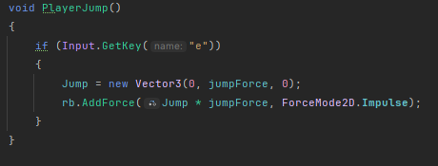altered the code again but nothing changed

I then removed the Impulse from the line, and the player now jumped but it was quite simple and didn’t work very well, I wanted to add it back in to make it seem more like a proper jump. The player also fell slowly so I increased the gravity scale to about 30, as that seemed to mimic real life gravity more accurately.

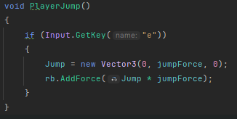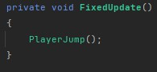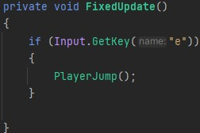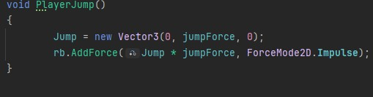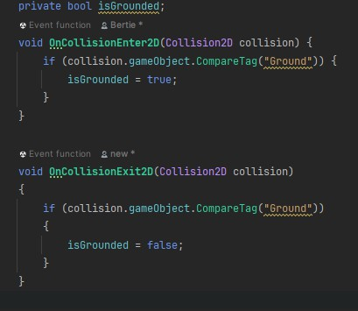

I then moved the player jump to FixedUpdate, which is better for physics- based functions than just the Update function. But the player still didn’t jump when the button was pressed.

I then decided to take the inputs for the movement functions in Update rather than in their specific functions, as I thought it may change something.

I decided to move on as it still wasn’t jumping, I added 2 functions to see if the player was on the ground and to return true or false, I then edited the if statement inside the function to require isGrounded to equal true, to allow the player to jump.

After this, based on my test plan, I now need to add a way for the player to respawn, I have already done a chunk of this by creating the teleport function, so now all I need to do is teleport the player to a certain point when they die. The first thing I did was create a variable for the player’s spawn point – which will be used to teleport the player to, as it will change for each level. I then made a function which will change the players location to the x, y and z coordinates of the spawn point variable.

I then created a function which checks for the collision of the player and the ‘death barrier’. I wasn’t sure of how to implement this into teleporting a player, but my first idea was to put both routines into the Update function. There was an error where the OutOfBounds procedure wasn’t working.

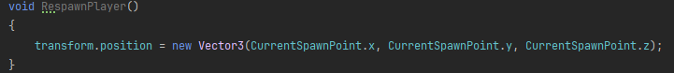

My first attempt of fixing this was to change the name of the subroutine to OnCollisionEnter2D, so Unity calls it automatically when the objects collide. This worked and there were no errors. I then wanted to set the coordinates if the spawn point when the player starts the game. I wanted to do this in the PlayerMovement class, because that is where I put most of the code for the player. This would require me to write a getter and setter for the private variable, which is helpful as I will be using it in many different classes to set the spawn point of the player. I didn’t know how to do this in C# so I used (w3schools, 2025) to help me create a getter and setter. In the player movement class, I again did not know how to get the getter to work. Eventually, I decided to temporarily make it public, so I could continue working. After I had added the CurrentSpawnPoint variable to the other class, it still didn’t work, due to an error of not being able to convert an integer coordinate to a Vector3. I fixed this by adding a ‘new’ in front of it.



